- Read again the first part of the source from lines 4 – 8.
List four things you learn from this part of the text about what can be seen outside of the window. [4 marks]

- Look in detail at this extract from lines 9 – 24 of the Source.
Conor could also see the great yew tree that rose from the centre of the graveyard, a tree so ancient it almost seemed to be made of the same stone as the church. He only knew it was a yew because his mother had told him, first when he was little to make sure he didn’t eat the berries, which were poisonous, and again this past year, when she’d started staring out of their kitchen window with a funny look on her face and saying, “That’s a yew tree, you know.”
And then he heard his name again.
Conor.
Like it was being whispered in both his ears.
“What?” Conor said, his heart thumping, suddenly impatient for whatever was going to happen.
A cloud moved in front of the moon, covering the whole landscape in darkness, and a whoosh of wind rushed down the hill and into his room, billowing the curtains. He heard the creaking and cracking of wood again, groaning like a living thing, like the hungry stomach of the world growling for a meal.
Then the cloud passed, and the moon shone again.
On the yew tree.
Which now stood firmly in the middle of his back garden.
And here was the monster.

How does the writer use language here to describe the setting?

You could include the writer’s choice of:
- Words and phrases
- Language features and forms
- Sentence forms [8 marks]

- You now need to think about the whole of the Source.
This text is from the opening of a novel. How has the writer structured the text to interest you as a reader?
You could write about:
- What the writer focuses your attention on in the beginning
- How and why the writer changes the focus as the Source develops
- Any other structural features that interest you. [8 marks]

- Focus this part of your answer on the second part of the Source from line 25 to the end.

A student, having read this section of the text, said: “The writer manages to effectively bring the monster to life for the reader. The way that the writer describes Conor’s reaction is unusual and makes the reader curious.” To what extent do you agree?

In your response you could:
- Write about your own impressions of the monster and Conor
- Evaluate how the writer has created these impressions
- Support your opinions with reference to the text [20 marks]
Section B: Writing

You are advised to spend about 45 minutes on this section.
Write in full sentences.
You are reminded of the need to plan your answer.
You should leave enough time to check your work at the end.

- A magazine has asked for contributions for their creative writing section.

Either

Write a description suggested by this picture:
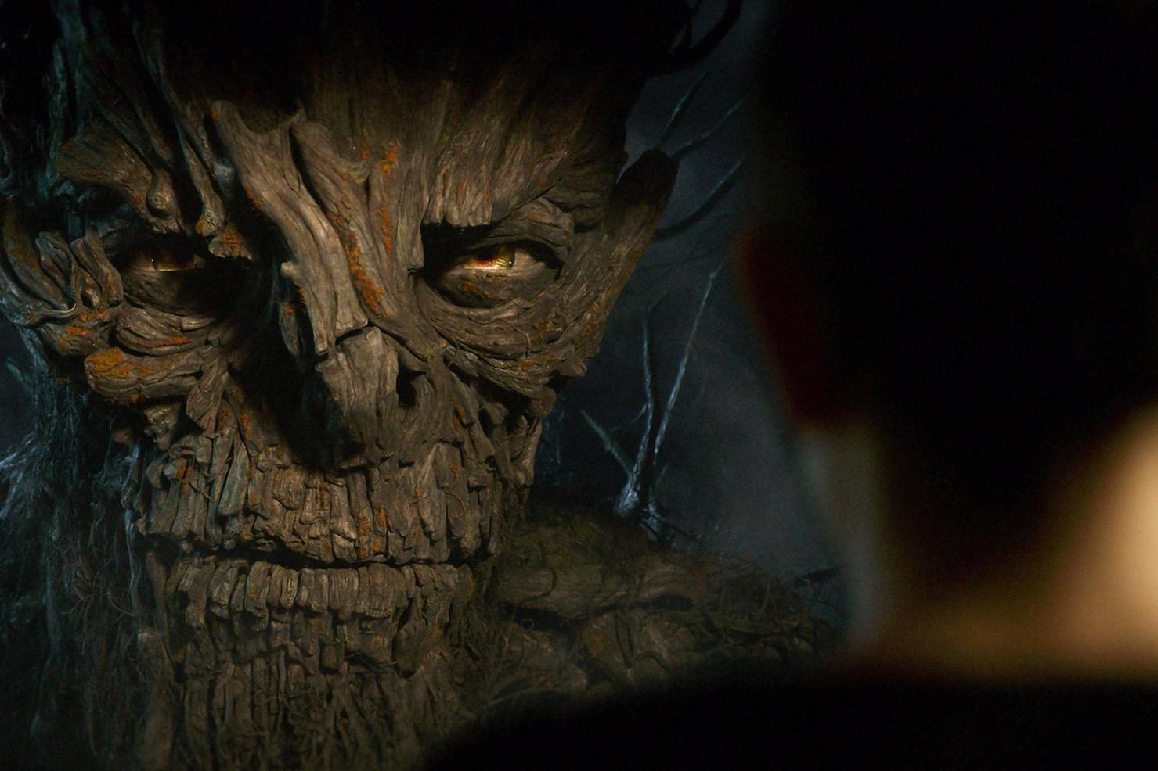

Or

Write a story where something extraordinary happens.

(24 marks for content and organisation
16 marks for technical accuracy)
[40 marks]

